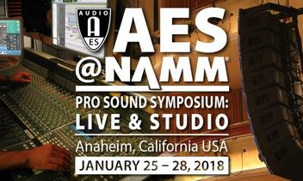 | AES@NAMM Symposium  Media Release  Mark Frink, Director, Programming & Content  aes@markfrink.com | 904.307-9971  Mel Lambert, Manager, Marketing & Promotions  mel.lambert@earthlink.net | 818.558-3924

FOR IMMEDIATE RELEASE
AES@NAMM Pro Sound Symposium unveils
rich and varied program of educational training sessions
- Well-known presenters will address a broad range of live-sound and studio topics -

New York City, December 15, 2017 — With a full schedule for the inaugural AES@NAMM Pro Sound Symposium: Live & Studio now online at both the AES and NAMM websites, participants will be able to review the rich and varied educational program and select technical and training sessions they would like to attend. The four-day international symposium from the Audio Engineering Society, which will be held at the 2018 NAMM Show from January 25-28 in Anaheim, CA, is targeted at working professionals in the live sound, recording and performance-audio communities. The program comprises a series of Training Academies and related sessions on line-array technologies, live-sound mixing consoles, wireless systems, in-ear monitoring and recording studio environments, in addition to tutorials on system measurement and optimization, plus a selection of technical papers in related fields. Classes will be held within the Anaheim Hilton Hotel’s NAMM U Education Center, adjacent to a new pro-audio exhibit space. The entire schedule of nearly 300 sessions can be accessed here: https://www.namm.org/thenammshow/2018/events/education/aes

In addition to the Line Array Loudspeaker Academy, with program supporters Adamson, Bose Professional, dB Technologies and EAW, the Live Mixing Console Academy with QSC and Yamaha, and Entertainment Wireless Academy with Lectrosonics and Sennheiser, stand-out tutorials and workshops include Main Stage: Studio, Main Stage: Live and Sound System Measurement & Optimization. Other symposium supporters and technical participants in The Studios sessions include Apogee, DigiGrid, Digital Audio Denmark, Eventide, Focal, Genelec, Meyer Sound Laboratories and Waves/Soundgrid.

Main Stage: Live sessions will cover contemporary live sound-system mixing and concert system engineering, with support and participation from top-tier rental sound company owners and leading FOH mixers. Individual presentations and technical tutorials will be offered on live digital mixing console automation, virtual soundchecks, low-frequency management in live concert venues, world-tour logistics and more, as well as daily panels on other popular live-sound topics. During the four days of sessions, participating expert speakers joining veteran FOH host Robert Scovill include Rat Sound founder Dave Rat, Sound Image president Dave Shadoan, ATK/Audiotek president Michael MacDonald, and several surprise guests. Pat Baltzell of Baltzell Audio Design will reveal details of his experiences mixing live entertainment segments for the Superbowl halftime shows. The unique challenges of co-mixing FOH for the Sting/Paul Simon Tour will be highlighted by Coach Conner (FOH, Paul Simon) and Clair Global senior system engineer Howard Page (FOH, Sting).

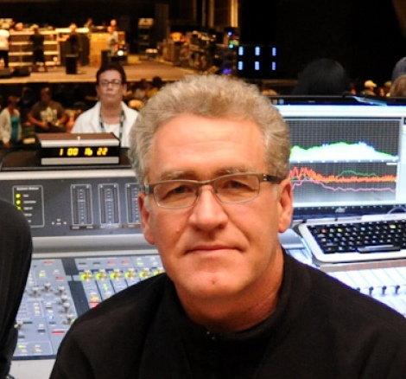 |  | 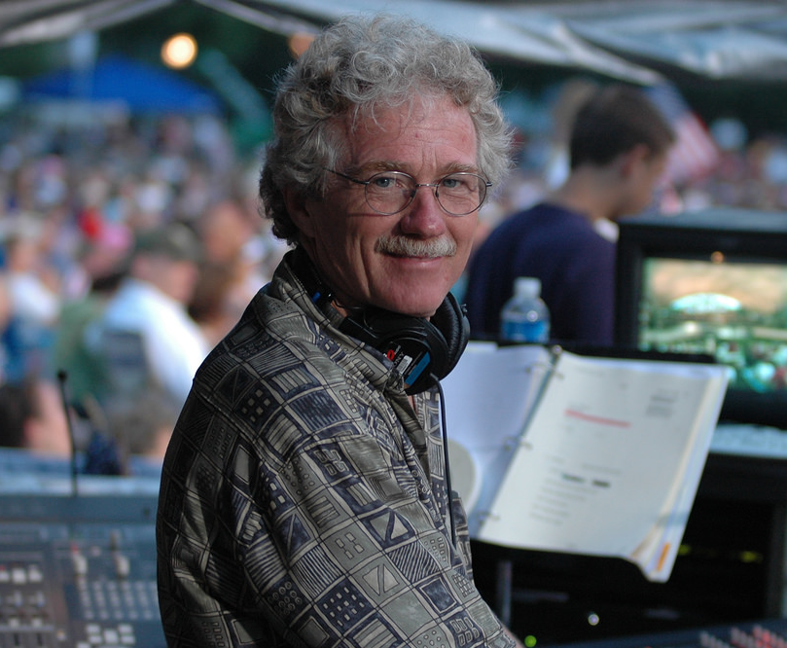 | 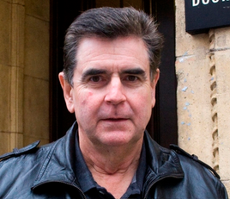 | 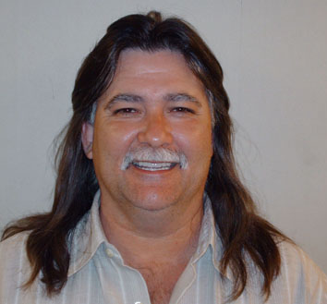
Robert Scovill | Dave Rat | Patrick Baltzell | Howard Page | Dave Shadoan
Click here for online release where high res photos can be downloaded by clicking on images

Hosted by producer/engineer/author Bobby Owsinski, Main Stage: Studio presentations occur hourly during all four days from such industry experts as Andrew Scheps, Sylvia Massy, Gavin Lurssen, Richard Chycki, Scott Gershin and many more. Topics range from Outside-the-Box Recording Techniques and Virtual Microphones to Alternative Studio Design and DIY Projects; they also focus on business, social media and creativity topics.

Sound System Measurement & Optimization Workshop, hosted by John Murray of Optimum Systems, will include breakout classrooms on AFMG’s SysTune, Rational Acoustics’ Smaart and Studio Six Digital’s Audio Tools. Sessions include Bruce Olson addressing Delay Fill Alignment, Charlie Hughes’s famous Subwoofer Series, Jamie Anderson on Multi-Mic Measurement, Chris Tsanjouries on Crossing the Art/Science Line and Andrew Smith on Choosing the Right Frequency Analyzer.

“This unique, new Audio Engineering Society AES@NAMM Symposium will spotlight the application of audio science and technology to sound-system operations, along with studio workflow practices,” emphasizes AES president David Scheirman. Advance registration costs are $99 for a full-day session or $69 for a half-day session; prices for non-AES members are $129 and $89, respectively. Non-members are encouraged to join the Society prior to purchasing Access Passes for the symposium program to receive the discounted price.

“We're pleased to be a part of the inaugural AES@NAMM programming at The NAMM Show 2018,” says Marc Weber, director of product and brand management with Adamson Systems Engineering. “NAMM's effort to boost the live-performance audio presence at this year's show is very encouraging.” “Bose Professional will be providing hands-on training for our compact line array assembly with DeltaQ technology, along with details of our collaboration with Powersoft's DSP and amplification platform,” adds Jeff Lange, the firm’s global loudspeaker trainer.

The equally important Social Events Program includes “Live Sound, Lessons Learned,” a Press Invitational that will honor the memory of Audio Analysts’ Albert Leccese on Thursday; an AES@NAMM Student Mixer on Friday; and a Saturday cocktail reception honoring women working in professional audio, organized by the Society’s new AES Diversity and Inclusion Committee.

The Technical Papers Sessions of peer-reviewed papers that are standard fare for such AES gatherings will be book-ended by Chinese-language sessions on selected pro-audio topics curated and presented by Bing Li, who chairs the AES Guangzhou Professional Section, together with Xiaowei Fan, lecturer on acoustics at Communication University of China, Nanjing College. Spanish-language sessions on studio recording workflow processes will also be presented and curated by Juan de Dios Martin, an experienced producer/engineer and Avid Pro Tools practitioner.

More: www.AESatNAMM.com | Facebook AES at NAMM 2018| Twitter @NAMMShow

790 words

About NAMM
The National Association of Music Merchants (NAMM) is the not-for-profit association with a mission to strengthen the $17 billion music products industry. NAMM is comprised of approximately 10,300 members located in 104 countries and regions. NAMM events and members fund The NAMM Foundation's efforts to promote the pleasures and benefits of music, and advance active participation in music making across the lifespan. For more information about NAMM, visit www.namm.org, call 800. 767.NAMM (6266) or follow the organization on Facebook, Instagram and Twitter.

About the Audio Engineering Society
The Audio Engineering Society was formed in 1948 and now counts over 12,000 members throughout the U.S., Latin America, Europe, Japan and the Far East. The organization serves as the pivotal force in the exchange and dissemination of technical information for the industry. Currently, its members are affiliated with more than 75 AES professional sections and more than 95 AES student sections around the world. Section activities may include guest speakers, technical tours, demonstrations and social functions. Through local AES section events, members experience valuable opportunities for professional networking and personal growth. For additional information visit http://www.aes.org and our social media sites

AES@NAMM Symposium Marketing Communications:
Mel Lambert | Content Creators | mel.lambert@earthlink.net | +1 818.558-3924.

